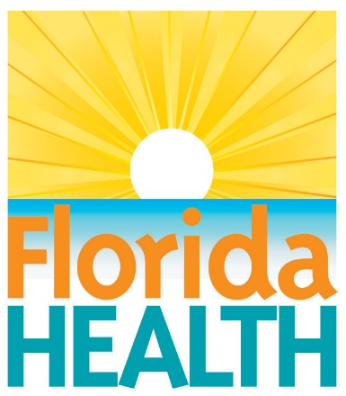
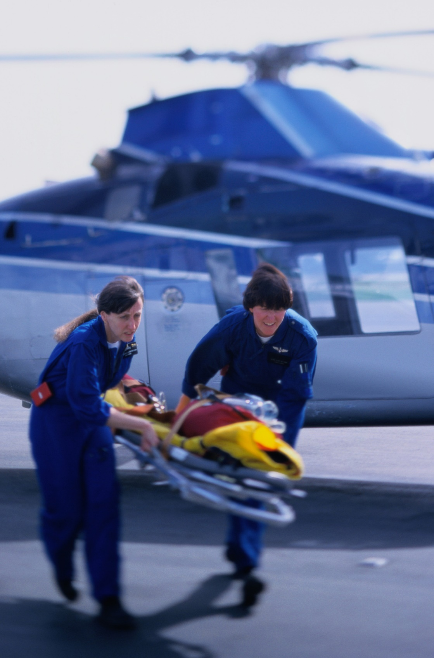

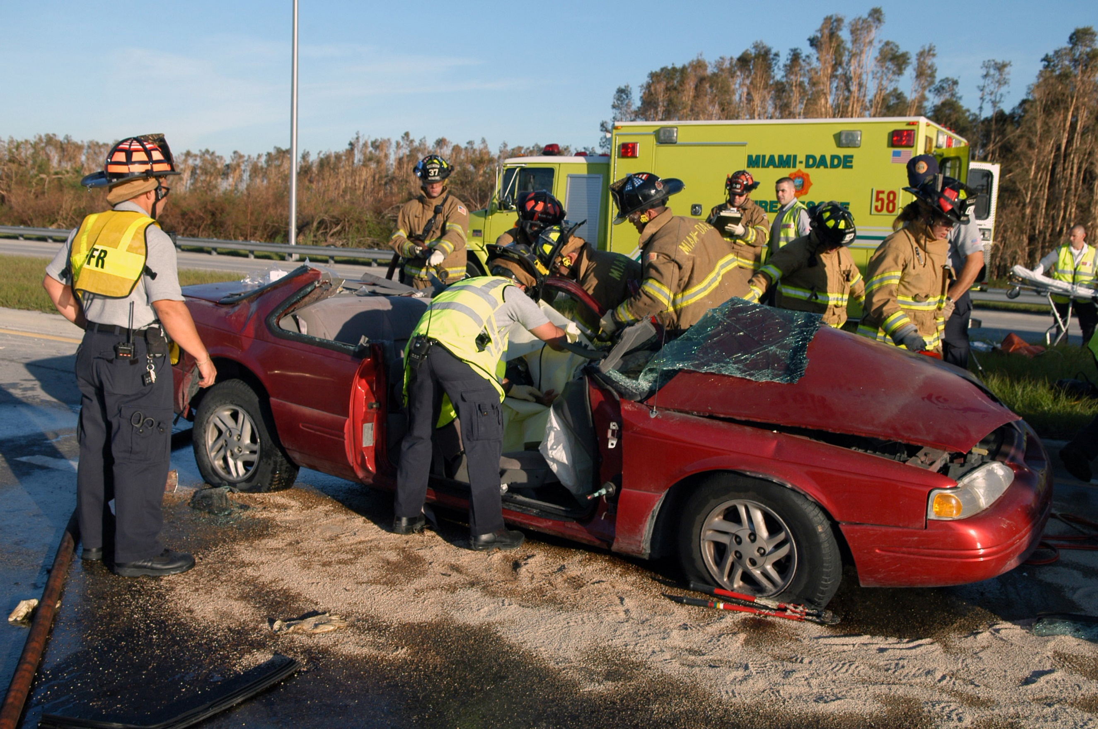

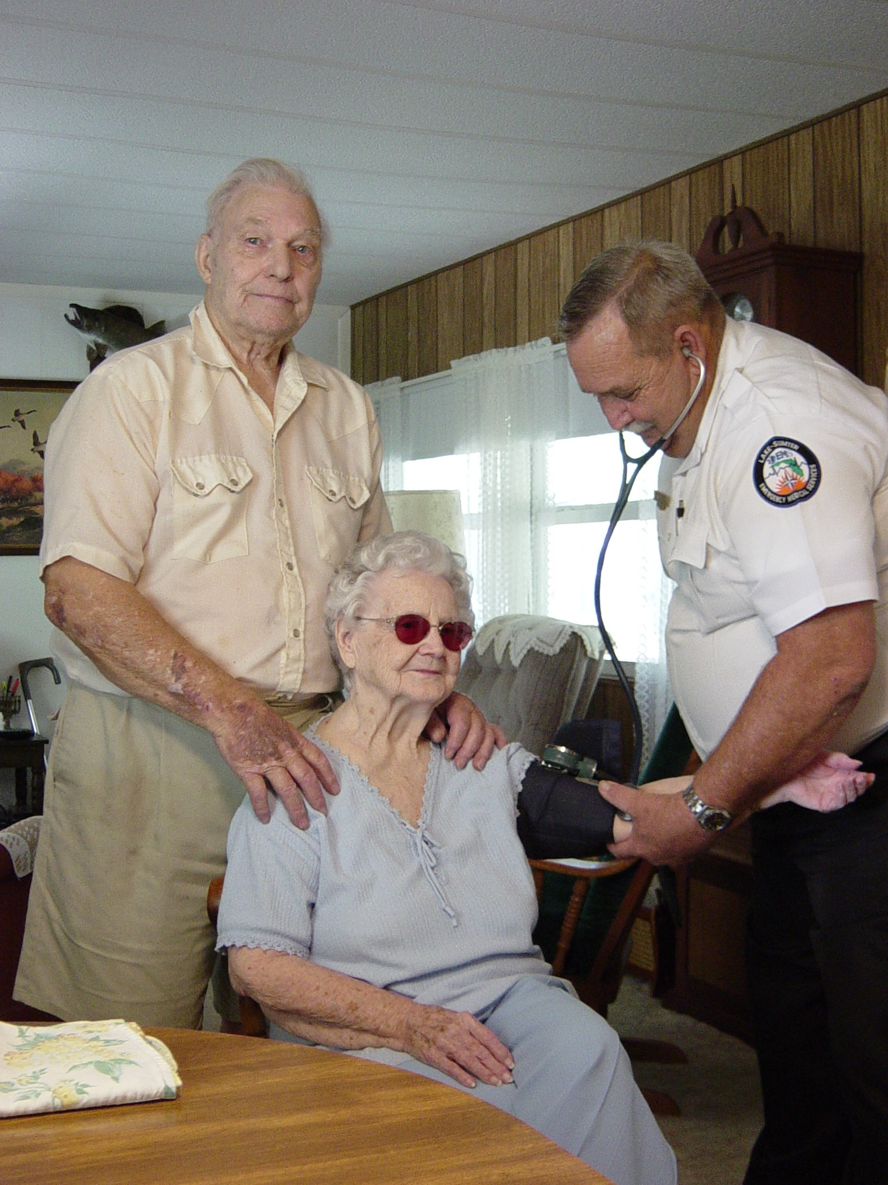

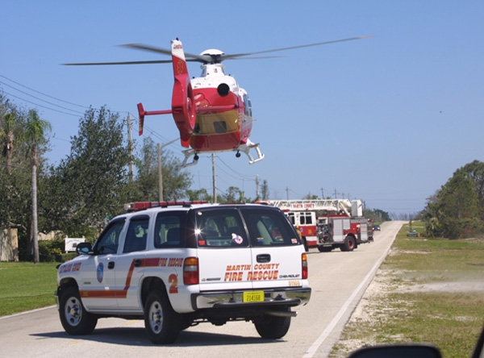

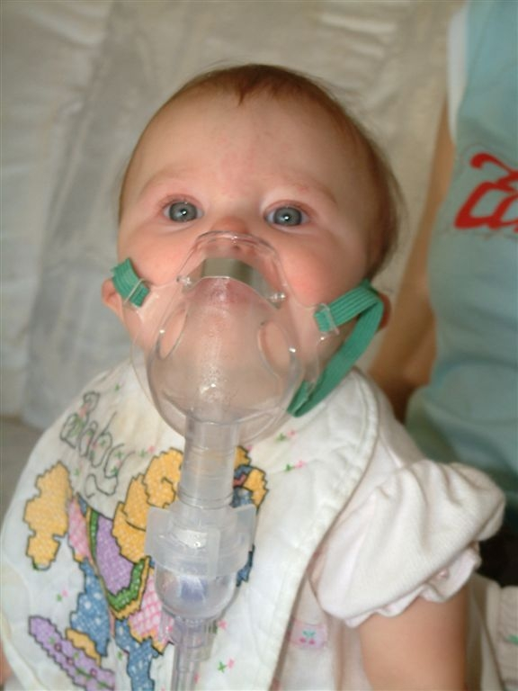

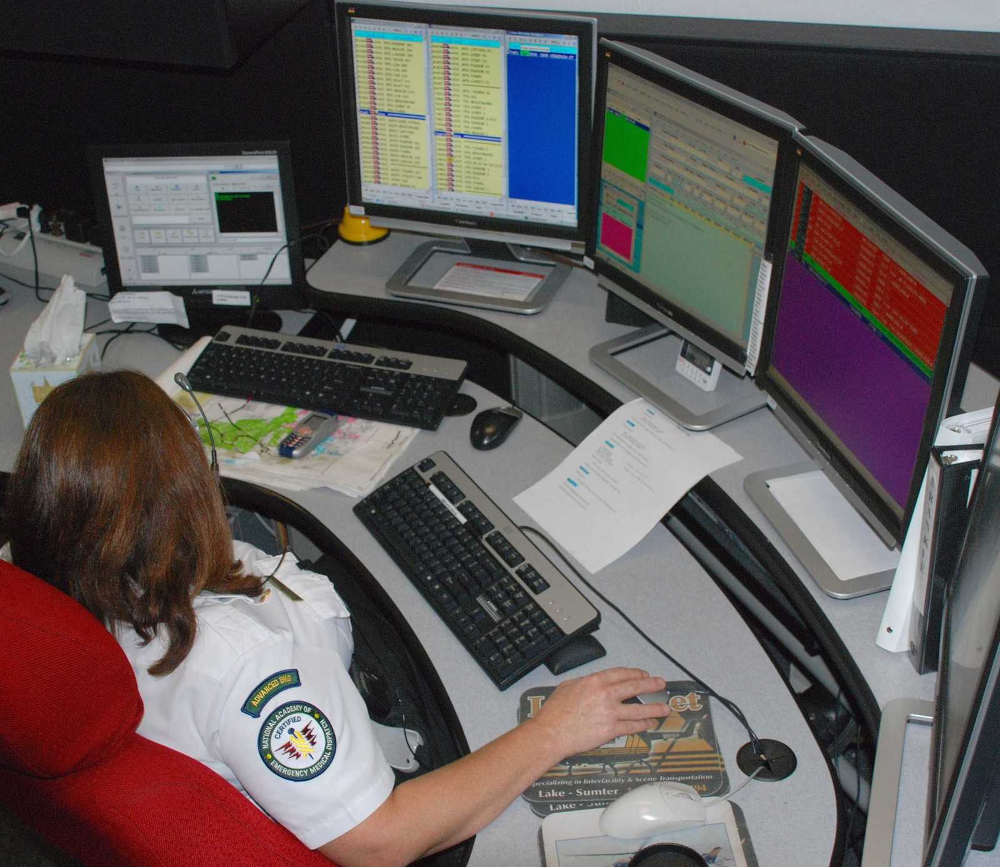

Ron DeSantis
GOVERNOR

Florida Department of Health
Emergency Medical Services State Plan
2016-2021

Version 1.20
January 2019

Produced by:
Florida Department of Health and
Florida Emergency Medical Services (EMS) Advisory Council
4052 Bald Cypress Way, Bin # A22
Tallahassee, Florida 32399-1722
Table of Contents
Contents
Executive Summary 1
Mission, Vision and Values 1
Strategy Map 2
Strategic Priorities 4
Strategic Priority 1: EMS Industry Health and Safety 4
Strategic Priority 2: Clinical and Operational Performance 4
Strategic Priority 3: EMS System Infrastructure and Finance 5
Strategic Priority 4: Readiness for Emerging Health Threats 6
Strategic Priority 5: Community Redevelopment and Partnerships 6
Strategic Priority 6: Regulatory Efficiency 7
Appendices 8
Appendix A: Florida EMS State Planning Summit Participants 8
Appendix B: Planning Summary 9
Appendix C: Monitoring Summary 10
Appendix D: Alignment 12
Appendix E: Environmental Scan Resources 16
Appendix F: Document Change Log 17

Executive Summary

Section 401.24, Florida Statutes (F.S.), requires the Florida Department of Health (DOH) to develop and revise every five years a comprehensive state plan for basic and advanced life support services. At a minimum, the plan must include emergency medical systems planning, requirements for the operation, coordination and ongoing development of emergency medical services, and the definition of areas of responsibility for regulating and planning the ongoing and developing delivery service requirements.

In May of 2016, the Bureau of Emergency Medical Oversight (BEMO), Emergency Medical Services (EMS) Section conducted a planning summit in coordination with the EMS Advisory Council (EMSAC) and EMS stakeholders to develop the Emergency Medical Services State Plan, 2016-2021. This plan is designed to be a framework to strengthen Florida’s EMS system to achieve one vision: a unified EMS system that provides evidence-based prehospital care to the people of Florida and serves as the recognized leader in EMS response nationwide. It is a living document that will be evaluated and updated regularly to address new challenges posed by the changing environment of public health in Florida.

In creating the EMS State Plan, the bureau reviewed the State Health Improvement Plan, the Department of Health Strategic Plan, and the EMS Advisory Council Strategic Plan in an effort to align strategic priorities, goals and objectives. This alignment will provide Florida EMS with a road map to future statewide collaborative efforts within the continuum of care and become a catalyst for more involvement in Florida’s public health initiatives.

Mission, Vision and Values

Mission – Why do we exist?
To protect, promote and improve the health of all people in Florida through integrated state, county and community efforts.

Vision – What do we want to achieve?
To be the Healthiest State in the Nation.

Values – What do we use to achieve our mission and vision?
I nnovation: We search for creative solutions and manage resources wisely.
C ollaboration: We use teamwork to achieve common goals and solve problems.
A ccountability: We perform with integrity and respect.
R esponsiveness: We achieve our mission by serving our customers and engaging our partners.
E xcellence: We promote quality outcomes through learning and continuous performance
improvement.

- Identify the actual number of EMS related collisions and the causation, and develop a plan to reduce these collisions by 2021
- By December 2019, complete an analysis of patients under the age of four years who are transported in an EMS permitted vehicle in a child restraint device
- By December 31, 2020, identify options for an anonymous statewide EMS medical error data collection tool and process

Objectives
- Improve wellness, fitness and safety among EMS agencies
- Improve safety of pediatric transport in EMS permitted vehicles
- Reduce EMS medical errors

Strategy Map
Strategies
EMS Industry Safety
Goal 1.0 - Ensure a commitment to the health and safety of the EMS industry and the citizens and visitors of Florida
Strategic Priority Areas

- Increase the number of emergency runs submitted to EMSTARS from 90% to 95% by June 2019
- Increase the number of automated data linkages between EMSTARS and other relevant databases from 1 to 4 by December 2019
- Increase the percent of non-traumatic cardiac arrest patients who receive bystander Cardiopulmonary Resuscitation (CPR) from 7% to 20% by December 2020
- Increase the percentage of non-traumatic cardiac arrest patients who develop a Return of Spontaneous Circulation (ROSC), both prehospital and upon arrival to emergency department (ED), from 16.32% to 20.34% by December 2020
- Increase the percentage of ST Elevation Myocardial Infarction (STEMI) alert events in which the on-scene time is less than or equal to 20 minutes to 90% by December 2020
- Increase the percentage of STEMI alert patients who were transported to a Level I or Level II Cardiovascular Hospital from 68% to 90% by December 2020
- Increase the percent of stroke alert events in which the on-scene time is less than or equal to 20 minutes from 67% to 90% by December 2020
- Increase the percentage of stroke alert patients that were initially transported to a primary or comprehensive state stroke facility from 69% to 90% by December 2018
- Increase the percentage of trauma alert events in which the total on-scene time is less than or equal to 20 minutes from 40% to 90% by December 2020
- Increase the percentage of trauma alert patients who were initially transported to a trauma center to 90% by December 2020

- Promote quality patient care and outcomes
- Promote the accessibility and use of Emergency Medical Services Tracking and Reporting System (EMSTARS) data to drive performance improvement initiatives

Clinical and Operational Performance
Goal 2.0 - Use health information technology to improve the efficiency, effectiveness and quality of patient care coordination and health care outcomes

EMS System Infrastructure and Finance
Goal 3.1 - Attract, recruit and retain a prepared, diverse and sustainable EMS workforce in all geographic areas of Florida

Goal 3.2 - Establish a financially sustainable infrastructure, which includes processes and effective use of technology and communication supporting all EMS systems functions

- Improve financial stability and sustainability of Florida EMS systems
- Increase the pool of qualified applicants for EMS positions with emphasis on veterans and diversity
- Improve the evolution of interoperable communications between counties
- Increase funding for Florida’s EMS system
- Achieve national EMS education program accreditation for initial paramedic training programs and adopt national EMS testing for initial certification only

- Increase the racial diversity from a 28.5% minority workforce in Florida EMS to 38.5% by December 2020
- Increase the gender diversity of emergency medical technicians (EMT) and paramedics in the workforce by 1% per year over the next five years
- By June 1, 2020, complete a second analysis that determines the counties that have 800 Megahertz (MHz) or 700 MHz trunked radio systems aligned with Florida’s Project 25 ID Numbering Plan
- Increase the percentage of EMS agencies that subscribe to FirstNet/FloridaNet from 0% to 30% by July 2021
- All initial EMS training programs in the state of Florida will achieve national accreditation by December 31, 2020
- Institute national EMS testing for initial certification by December 31, 2023
- By December 2019, increase the percentage of state level revenue for the improvement and expansion of emergency medical services by 25%
- Explore and define four alternative revenue sources to support EMS in the state by December 31, 2019

Readiness for Emerging Health Threats

Goal 4.0 - Demonstrate EMS readiness for emerging health threats and natural or manmade disasters

- By December 31, 2020, increase the number of EMS agencies participating in annual Chemical, Biological, Radiological, Nuclear and Explosives (CBRNE) exercises and/or training from 23% to 33%
- By December 2020, increase the percentage of EMS agencies participating in health care coalitions from 45% to 55%
- By January 2020, at least 50% of licensed EMS agencies will use National Fire Protection Association (NFPA) 3000 on EMS management of active shooter/hostile events as guidelines toward best practices
- By December 31, 2020, increase the number of EMS agencies that have adopted plans and trained for an active shooter response from 48% to 75%
- By December 2020, increase the number of EMS agencies that are properly equipped to manage an active shooter event from 34% to 75%
- Implement an electronic resource program for ambulance deployment and tracking by December 2020

- Increase Florida’s National Health Security Preparedness Index (NHSPI)
- Increase financial support for EMS readiness
- Increase Florida readiness to respond to natural or manmade disasters

Strategic Priority Areas
Community Redevelopment and Partnerships
Goal 5.0 - Integrate EMS with health planning and assessment processes to maximize community partnerships and expertise in accomplishing its goals
Strategies
- Provide injury prevention programs to the public
- Promote the increase of EMS agencies developing community paramedic programs (all objectives)
- Improve community health (all objectives)
Objectives
- Increase the percentage of EMS agencies conducting or participating in fall prevention programs from 28.5% to 40% by December 2019
- Increase the percentage of EMS agencies conducting or participating in opioid use and naloxone awareness programs from 13.5% to 35% by December 2019
- Increase the percentage of EMS agencies conducting or participating in safety programs sponsored or recommended by the Florida Department of Transportation (FDOT) from 19.2% to 30% by December 2019
- Increase the percentage of EMS agencies conducting or participating in drowning prevention programs from 30% to 50% by December 2019
- Increase the percentage of EMS agencies conducting or participating in programs to reduce infant mortality from 18.5% to 30% by December 2019
- Increase the percentage of EMS agencies offering cardiovascular health and wellness programs pursuant to section 401.272, F.S., from 72% to 80% by December 2020
- Increase the percentage of EMS agencies providing or participating in human immunodeficiency virus (HIV) health and wellness programs pursuant to section 401.272, F.S., from 6.4% to 25% by December 2019
- Reduce the number of adult low acuity ED visits from 14.15% to 10% by December 2019
- Increase the number of EMS agencies with protocols that actively refer children and adults for early intervention and treatment of mental health disorders from 8.7% to 10% by December 2019
- Increase the percentage of EMS agencies offering immunization programs pursuant to section 401.272, F.S., from 6.4% to 25% by December 2019

Regulatory Efficiency

Goal 6.0 - Establish a regulatory structure that supports the EMS system’s strategic priorities

- Promote the ethical and professional practice of prehospital medicine in Florida
- Establish and promote a quality based EMS inspection process

- Increase the number of EMS agencies using a performance-based inspection process from 0 to 180 by July 2020

Strategic Priorities

Strategic Priority 1: EMS Industry Health and Safety
Goal 1.0: Ensure a commitment to the health and safety of the EMS industry and the citizens and visitors of Florida

Strategy | Objective |  | Owner
1.1 Improve wellness, fitness and safety among EMS agencies | A | Identify the actual number of EMS related collisions and the causation and develop a plan to reduce these collisions by 2021 | Public Information Education Relations (PIER)
1.2 Improve safety of pediatric transport in EMS permitted vehicles | A By December 2019, complete an analysis of patients under the age of four years who are transported in an EMS permitted vehicle in a child restraint device |  | Emergency Medical Services for Children (EMSC)
1.3 Reduce EMS medical errors | A By December 31, 2020, identify options for an anonymous statewide EMS medical error data collection tool and process |  | Medical Care

Strategic Priority 2: Clinical and Operational Performance
Goal 2.0: Use health information technology to improve the efficiency, effectiveness and quality of patient care coordination and health care outcomes

Strategy | Objective |  | Owner
2.1 Increase the accessibility and use of EMSTARS data to drive performance improvement initiatives | A | Increase the number of emergency runs submitted to EMSTARS from 90% to 95% by June 2019 | Data
 | B | Increase the number of automated data linkages between EMSTARS and other relevant databases from 1 to 4 by December 2019 | Data
2.2 Improve patient care quality and outcomes | A | Increase the percent of non-traumatic cardiac arrest patients who receive bystander CPR from 7% to 20% by December 2020 | Medical Care
 | B | Increase the percentage of non-traumatic cardiac arrest patients who develop a ROSC, both prehospital and upon arrival to ED, from 16.32% to 20.34% by December 2020 | Medical Care
 | C | Increase the percentage of STEMI alert events in which the on-scene time is less than or equal to 20 minutes to 90% by December 2020 | Medical Care
 | D | Increase the percentage of STEMI alert patients who were transported to a Level I or Level II Cardiovascular Hospital from 68% to 90% by December 2020 | Medical Care
 | E | Increase the percent of stroke alert events in which the on-scene time is less than or equal to 20 minutes from 67% to 90% by December 2020 | Medical Care
 | F | Increase the percentage of stroke alert patients who were initially transported to a primary or comprehensive state stroke facility from 69% to 90% by December 2020 | Medical Care
 | G | Increase the percentage of trauma alert events in which the total on-scene time is less than or equal to 20 minutes from 40% to 90% by December 2020 | Medical Care
 | H | Increase the percentage of trauma alert patients who were initially transported to a trauma center to 90% by December 2020 | Medical Care

Strategic Priority 3: EMS System Infrastructure and Finance
Goal 3.1: Attract, recruit and retain a prepared, diverse and sustainable EMS workforce in all geographic areas of Florida

Goal 3.2: Establish a financially sustainable infrastructure, which includes processes and effective use of technology and communication supporting all EMS systems functions

Strategy | Objective |  | Owner
3.1 Increase the pool of qualified applicants for EMS positions with emphasis on veterans and diversity | A | Increase the racial diversity from a 28.5% minority workforce in Florida EMS to 38.5% by December 2020 | Education
 | B | Increase the gender diversity of EMTs and paramedics in the workforce by 1% per year for the next five years | Education
3.1.2 Improve the evolution of interoperable communications between counties | A | By June 1, 2020, complete a second analysis that determines the counties that have 800 MHz or 700 MHz trunked radio systems aligned with Florida’s Project 25 ID Numbering Plan | Communications
 | B | Increase the percentage of EMS agencies that subscribe to FirstNet/FloridaNet from 0% to 30% by July 2021 | Communications
3.1.3 Achieve national EMS education program accreditation for initial paramedic training programs and adopt national EMS testing for initial certification only | A | All initial EMS training programs in the state of Florida will achieve national accreditation by December 31, 2020 | Education
 | B | Institute national EMS testing for initial certification by December 31, 2023 | Education
3.2 Increase funding for Florida’s EMS system | A | By December 2019, increase the percentage of state level revenue for the improvement and expansion of emergency medical services by 25% | Access to Care
 | B | Explore and define four alternative revenue sources to support EMS in the state by December 31, 2019 | Access to Care

Strategic Priority 4: Readiness for Emerging Health Threats
Goal 4.0: Demonstrate EMS readiness for emerging health threats and natural or manmade disasters

Strategy | Objective |  | Owner
4.1 Increase Florida’s National Health Security Preparedness Index (NHSPI) | A | By December 31, 2020, increase the number of EMS agencies participating in annual CBRNE exercises and/or training from 23% to 33% | Disaster
 | B | By December 2020, increase the percentage of EMS agencies participating in health care coalitions from 45% to 55% | Disaster
 | C | By July 2020, at least 50% of licensed EMS agencies will use NFPA 3000 on EMS management of active shooter/hostile events as guidelines toward best practices | Disaster
 | D | By December 31, 2020, increase the number of EMS agencies that have adopted plans and trained for an active shooter response from 48% to 75% | Disaster
 | E | By December 2020, increase the number of EMS agencies that are properly equipped to manage an active shooter event from 34% to 75% | Disaster
4.2 Increase Florida readiness to respond to natural or manmade disasters | A | Implement an electronic resource program for ambulance deployment and tracking by December 2020 | Disaster

Strategic Priority 5: Community Redevelopment and Partnerships
Goal 5.0: Integrate EMS with health planning and assessment processes to maximize community partnerships and expertise in accomplishing its goals

Strategy | Objective |  | Owner
5.1 Reduce injury | A | Increase the percentage of EMS agencies conducting or participating in fall prevention programs from 28.5% to 40% by December 2019 | PIER
 | B | Increase the percentage of EMS agencies conducting or participating in opioid use and naloxone awareness programs from 13.5% to 35% by December 2019 | PIER
 | C | Increase the percentage of EMS agencies conducting or participating in safety programs sponsored or recommended by the FDOT from 19.2% to 30% by December 2019 | PIER
 | D | Increase the percentage of EMS agencies conducting or participating in drowning prevention programs from 30% to 50% by December 2019 | PIER
 | E | Increase the percentage of EMS agencies conducting or participating in programs to reduce infant mortality from 18.5% to 30% by December 2019 | EMSC
5.2 Improve cardiovascular health | A | Increase the percentage of EMS agencies offering cardiovascular health and wellness programs pursuant to section 401.272, F.S., from 72% to 80% by December 2020 | Access to Care
5.3 Reduce HIV prevalence | A | Increase the percentage of EMS agencies providing or participating in HIV health and wellness programs pursuant to section 401.272, F.S., from 6.4% to 25% by December 2019 | PIER
5.4 Promote the increase of EMS agencies developing community paramedic programs | A | Reduce the number of adult low acuity ED visits from 14.15% to 10% by December 2019 | Access to Care
 | B | Increase the number of EMS agencies with protocols that actively refer children and adults for early intervention and treatment of mental health disorders from 8.7% to 10% by December 2019 | Access to Care
5.5 Increase vaccination rates for children and adults | A | Increase the percentage of EMS agencies offering immunization programs pursuant to section 401.272, F.S., from 6.4% to 25% by December 2019 | Access to Care

Strategic Priority 6: Regulatory Efficiency
Goal 6: Establish a regulatory structure that supports the EMS system’s strategic priorities

Strategy | Objective |  | Owner
6.1 Establish and promote a quality based EMS inspection process | A | Increase the number of EMS agencies using a performance-based inspection process from 0 to 180 by July 2020 | Data

Appendices

Appendix A

Appendix A: Florida EMS State Planning Summit Participants
Florida EMS Advisory Council
Julie Bacon  EMS Advisory Council  All Children’s Hospital | Carlton Wells  EMS Advisory Council  Department of Management Services | Babette Bailey  Florida Aeromedical Association
Cory Richter  EMS Advisory Council Strategic Visions Subcommittee  Indian River County Fire Rescue | EMS Constituency | David Dyal  Florida Association of Emergency Medical Service Providers  Stuart Fire Rescue
Malcom Kemp  EMS Advisory Council  Leon County EMS | Patricia Byers  Florida Committee on Trauma  University of Miami Miller School of Medicine | Florida Department of Health Staff  Steve McCoy  EMS Administrator  Bureau of Emergency Medical Oversight
Tracy Yacobellis  EMS Advisory Council  Florida Department of Education | Debbie Vass  Florida Association of EMS Quality Managers  Sunstar EMS | Rickey Stone  Program Administrator  Bureau of Emergency Medical Oversight
Ann Brown  EMS Advisory Council  Florida Gateway College | Angel Nater  Florida Association of EMS Educators  Seminole State College | Bobby Bailey  Lead Exercise Coordinator  Bureau of Preparedness & Response
Darrell Donatto  EMS Advisory Council  Florida Fire Chiefs’ Association (FFCA) | Hezedean Smith  Orlando Fire Department | Melia Jenkins  EMS Planning Manager  Bureau of Emergency Medical Oversight
Isabel Rodriguez  EMS Advisory Council  American Medical Response | Michael Hall  Nature Coast EMS  Florida Ambulance Association | Kimberly Moore  Health Services Manager  Bureau of Emergency Medical Oversight
Michael Lozano  EMS Advisory Council  Hillsborough County Fire Rescue | John Peterson  Sunstar EMS | Joshua Sturms  Data Section Administrator  Bureau of Emergency Medical Oversight
Jane Bedford  EMS Advisory Council  Nature Coast EMS | Melissa Keahey  Emergency Medicine Learning & Resource Center  Florida Association of EMS Medical Directors | Bethany Lowe  Administrator  Bureau of Emergency Medical Oversight
Doris Ballard-Ferguson  EMS Advisory Council | Patrick Husic  Florida Neonatal and Pediatric Transport Association | Brenda Clotfelter  EMSTARS Project Manager  Bureau of Emergency Medical Oversight
Danny Griffin  EMS Advisory Council  Florida Association of EMS Educators | Michael Patterson  Florida Association of Rural EMS  Florida Association of County EMS  Putnam County Fire & EMS | Juan Esparza  Business Analyst  Bureau of Emergency Medical Oversight

Appendix B

Appendix B: Planning Summary

A multidisciplinary group of EMS stakeholders met several times over the past two years to complete this plan. This plan began in October of 2013 as a multifaceted strategic plan with numerous goals and objectives that were difficult to measure and improve upon. No action was taken on the plan until it was revisited in January of 2016. It was agreed upon by the Department and the EMS Advisory Council to revise the current strategic plan using relevant goals and measurable objectives that aligned with other public health initiatives. This resulted in a collaborative product between the Florida EMS Advisory Council, the Florida Department of Health, and EMS stakeholders.
The following is the EMS State Plan schedule of meetings and events:

meeting Date | Meeting Topic
July 2014 | Draft EMS Advisory Council Strategic Plan was finalized by the council
January 2016 | Revision concept was presented to the EMS Advisory Council and approved
March 3, 2016 | Initial State Plan Coordinator Meeting
April 15, 2016 | EMS State Plan Toolkit and environment scan completed
April 15, 2016 | Review and environmental scan comment period began
May 2, 2016 | State Plan Coordinator Meeting
May 4, 2016 -  May 5, 2016 | EMS State Planning Summit
June 1, 2016 | Environmental scan closed and final drafting period began
June 6, 2016 | First draft delivered to the EMS Advisory Council for review
June 6, 2016 | Comment period began
July 14, 2016 | EMS Advisory Council vote for approval
Sept 22, 2016 | DOH approval
Sept 22, 2016 | Publish final document
Oct 18, 2016 | Training session on EMS State Plan reporting tools and action plans

The first step in revising the current strategic plan was to use data from previous strategic planning efforts, as well as environmental scan results and other data sources, to develop measurable goals. Next, the Department created the EMS State Plan Toolkit. The toolkit includes a strategy map, which illustrates the alignment of the revised EMS State Plan goals, strategies, and objectives with other national and state public health initiatives such as, Healthy People 2020, the Florida State Health Improvement Plan, and the Agency’s Strategic Plan. Lastly, strategic planning coordinators worked with constituent groups and other EMS stakeholders during the EMS State Planning Summit to write and revise strategies and objectives for each goal. The revised document was sent to the EMS Advisory Council and Department leadership for comment and approval.

Appendix C

Appendix C: Monitoring Summary

The EMS State Plan is a component of a larger performance management system. A primary focus of this EMS State Plan is to integrate into other state and national strategic planning efforts. Many of the goals, strategies, and objectives within this plan will integrate into the Department’s overall performance management system, thereby promoting an EMS industry culture highlighting accountability and performance excellence.

The EMS Strategic Visions Team (EMS Advisory Council’s Strategic Visions Subcommittee and the Department) will be responsible for monitoring and reporting progress on the goals and objectives of the EMS State Plan. The Strategic Visions Team meets quarterly during EMS Advisory Council and constituent group meetings to discuss recommendations about tools and methods that integrate performance management into sustainable industry practice. Annually, an EMS State Plan progress report assessing progress toward reaching goals, objectives, and achievements for the year, will be developed and presented to Department executive leadership and the EMS Advisory Council. The EMS State Plan will be reviewed and revised by July each year based on an assessment of availability of resources, data and progress.

The EMS Strategic Visions Team includes goal owners, objective liaisons, and Department committee liaisons. The graph below outlines the roles of the specific individuals, their role in the state plan, and their constituent group or subcommittee.
Appendix D

Appendix D: Alignment

Objective | Healthy  2020 | SHIP | Agency  Plan | Subcommittee  Assigned To | Source
Identify the actual number of EMS related collisions and the causation and develop a plan to reduce these collisions by 2021 | OSH-1  OSH-2 | HP4.1 | 2.1.4 | PIER | FDOT Crash Database
By December 2019, complete an analysis of patients under the age of four years who are transported in an EMS permitted vehicle in a child restraint device | IVP-16 | HP4.1.3 | 2.1.4 | EMSC | EMSTARS 3.0
By December 31, 2020, identify options for an anonymous statewide EMS medical error data collection tool and process | MPS-3 | HP1.4 |  | Medical Care | N/A
Increase the number of emergency runs submitted to EMSTARS from 90% to 95% by June 2019 | PHI-7  PREP-19 | HP1.4  HP4.2 | 3.1.3 | Data | EMSTARS
Increase the number of automated data linkages between EMSTARS and other relevant databases from 1 to 4 by December 2019 | PHI-7  PREP-19 | HP1.3  HP4.2  HI1.1 | 3.1.3 | Data | EMSTARS
Increase the percent of non-traumatic cardiac arrest patients who receive bystander CPR from 7% to 20% by December 2020 | HDS-18  PREP-15 |  | 2.1.2 | Medical Care | EMSTARS
Increase the percentage of non-traumatic cardiac arrest patients who develop a ROSC, both prehospital and upon arrival to ED, from 16.32% to 20.34% by December 2020 | HDS-2  PREP-15 |  | 2.1.2 | Medical Care | EMSTARS
Increase the percentage of STEMI alert events in which the on-scene time is less than or equal to 20 minutes to 90% by December 2020 | HDS-19 |  | 2.1.2 | Medical Care | EMSTARS
Increase the percentage of STEMI alert patients who were transported to a Level I or Level II cardiovascular hospital from 68% to 90% by December 2020 | HDS-19 |  | 2.1.2 | Medical Care | EMSTARS
Increase the percent of stroke alert events in which the on-scene time is less than or equal to 20 minutes from 67% to 90% by December 2020 | HDS-19 |  | 2.1.2 | Medical Care | EMSTARS
Increase the percentage of stroke alert patients who were initially transported to a primary or comprehensive state stroke facility from 69% to 90% by December 2020 | HDS-19 |  | 2.1.2 | Medical Care | EMSTARS
Increase the percentage of trauma alert events in which the total on-scene time is less than or equal to 20 minutes from 40% to 90% by December 2020 | IVP-1 | HP4.3 | 2.1.4 | Medical Care | EMSTARS
Increase the percentage of trauma alert patients who were initially transported to a trauma center to 90% by December 2020 | IVP-1 | HP4.3 | 2.1.4 | Medical Care | EMSTARS
Increase the racial diversity from a 28.5% minority workforce in Florida EMS to 38.5% by December 2020 |  | HI3 |  | Education | LEIDS/Census
Increase the gender diversity of EMTs and paramedics in the workforce by 1% per year for the next five years |  | HI3 |  | Education | LEIDS/Census
By June 1, 2020, complete a second analysis that determines the counties that have 800 MHz or 700 MHz trunked radio systems aligned with Florida’s Project 25 ID Numbering Plan | PREP-2 |  | 3.1.3 | Communications | DMS
Increase the percentage of EMS agencies that subscribe to FirstNet/FloridaNet from 0% to 30% by July 2021. | PREP-2 |  | 3.1.3 | Communications | DMS
All initial EMS training programs in the state of Florida will achieve national accreditation by December 31, 2020 |  |  | 5.1.2 | Education | Department of Health/BEMO
Institute national EMS testing for initial certification by December 31, 2023 |  |  | 5.1.2 | Education | LEIDS
By December 2019, increase the percentage of state level revenue for the improvement and expansion of emergency medical services by 25% |  | HI2 | 4.1.3 | Access to Care | Department of Health/BEMO
Explore and define four alternative revenue sources to support EMS in the state by December 31, 2019 |  | HI2 | 4.1.3 | Access to Care | Department of Health/BEMO
By December 31, 2020, increase the number of EMS agencies participating in annual CBRNE exercises from 23% to 33% |  | HP3.2  HP3.5 | 3.1.3 | Disaster | Agency License Renewal Application
By December 2020, increase the percentage of EMS agencies participating in health care coalitions from 45% to 55% | PREP-18 |  |  | Disaster | Agency License Renewal Application
By July 2020, at least 50% of licensed EMS agencies will use NFPA 3000 on EMS management of active shooter/hostile events as guidelines toward best practices |  | HP3.2  HP3.6 |  | Disaster | Annual EMS System Survey
By December 31, 2020, increase the number of EMS agencies that have adopted plans and trained for an active shooter response from 48% to 75% |  | HP3.2  HP3.6 |  | Disaster | Annual EMS System Survey
By December 2020, increase the number of EMS agencies that are properly equipped to manage an active shooter event from 34% to 75% |  | HP3.2  HP3.6 |  | Disaster | Annual EMS System Survey
Implement an electronic resource program for ambulance deployment and tracking by December 2020 |  | HP3.2  HP3.6 |  | Disaster | Ambulance Deployment Plan
Increase the percentage of EMS agencies conducting or participating in fall prevention programs from 28.5% to 40% by December 2019 | IVP-23 | HP4.1 | 2.1.4 | PIER | Agency License Renewal Application
Increase the percentage of EMS agencies conducting or participating in opioid use and naloxone awareness programs from 13.5% to 35% by December 2019 | MPS-5 |  | 2.1.4 | PIER | Agency License Renewal Application
Increase the percentage of EMS agencies conducting or participating in safety programs sponsored or recommended by the FDOT from 19.2% to 30% by December 2019 | IVP-13  IVP-14  IVP-15 |  | 2.1.4 | PIER | Agency License Renewal Application
Increase the percentage of EMS agencies conducting or participating in drowning prevention programs from 30% to 50% by December 2019 | IVP-25 | HP4.1.2 | 2.1.4 | PIER | Agency License Renewal Application
Increase the percentage of EMS agencies conducting or participating in programs to reduce infant mortality from 18.5% to 30% by December 2019 | IVP-24.2 | AC5 | 1.1.1 | EMSC | Agency License Renewal Application
Increase the percentage of EMS agencies offering cardiovascular health and wellness programs pursuant to section 401.272, F.S., from 72% to 80% by December 2020 | HDS-2 |  | 2.1.2 | Access to Care | Agency License Renewal Application
Increase the percentage of EMS agencies providing or participating in HIV health and wellness programs pursuant to section 401.272, F.S., from 6.4% to 25% by December 2019 | HIV-2  HIV-3 | HP1.3 | 2.1.5 | PIER | Agency License Renewal Application
Reduce the number of adult low acuity ED visits from 14.15% to 10% by December 2019 | AHS-9 |  |  | Access to Care | Agency for Health Care Administration ED Report
Increase the number of EMS agencies with protocols that actively refer children and adults for early intervention and treatment of mental health disorders from 8.7% to 10% by December 2019 | MHMD-6  MHMD-9 |  |  | Access to Care | Agency License Renewal Application
Increase the percentage of EMS agencies offering immunization programs pursuant to section 401.272, F.S., from 6.4% to 25% by December 2019 | IID-1 | HP1.1 | 3.1.1 | Access to Care | Agency License Renewal Application
Increase the number of EMS agencies using a performance-based inspection process from 0 to 180 by July 2020 | PHI-16 | CR1.3  HI4.3 |  | Data | Department of Health (DOH)  LEIDS

Appendix E

Appendix E: Environmental Scan Resources

- Emergency Medical Services Advisory Council July 2014 – June 2019 DRAFT Strategic Plan
- Florida Department of Health Agency Strategic Plan 2016 - 2018
- Florida Injury Surveillance Data System
- Healthy People 2020 Topics and Objectives
- CDC Performance Measure Specifications and Implementation Guidance
- Agency for Health Care Administration (AHCA) Emergency Department Utilization Reports
- Emergency Medical Services Tracking and Reporting System
- National EMS Information System (NEMSIS)
- Florida Community Health Assessment Resource Tool Set (CHARTS)
- Florida Department of Transportation (FDOT) Crash Database
- The Florida Emergency Medical Services Communication Plan Volume I (Fourth Edition)
- Florida Veterans Application Licensure Online Response System (VALOR)
- United States Census Bureau Florida QuickFacts
- Licensing and Enforcement Information Database System (LEIDS)
- Florida Department of Health HIV Data Center
- United States Department of Labor, Bureau of Labor Statistics Occupational Outlook Handbook for EMTS and Paramedics
- Florida Department of Health Infant Mortality Documents and Data
- Drugs Identified in Deceased Persons by Florida Medical Examiners
- National Guidance for Healthcare System Preparedness
- U.S. Fire Administration, Fire/Emergency Medical Services Department Operational Considerations and Guide for Active Shooter and Mass Casualty Incidents
- State Working Group, Interoperable Communications Committee, Guide of Interoperability Components
- FloridaNet.gov Florida’s Public Safety Broadband Network
- EMS Workforce for the 21st Century: A National Assessment
- National Emergency Medical Services Workforce Data Definitions
- 2016 Annual EMS Agency Survey

Appendix F

Appendix F: Document Change Log
Change # | Document Version | Change Date | Description | Objective # | Page # | Name of Person or Committee Requesting Change | Approval Date
1 | 1.0 | 10/1/16 | The monitoring summary table was changed to reflect that the Strategic Priority Area of EMS System Infrastructure and Finance was owned by Education and Communications Committees and not the Data Committee. | N/A | 10 | Data | 10/1/16
2 | 1.0 | 2/15/17 | The monitoring summary table on page 11 was updated to reflect current work flows and changes in leadership roles. | N/A | 11 | Steve McCoy | 7/12/17
3 | 1.0 | 3/29/17 | Change the goal as indicated. The previous goal has been met and this allows for continued improvement. | 3.1A | 5 | Education | 7/12/17
4 | 1.0 | 3/29/17 | Changes the goal as indicated. The previous goal has been met and this encourages continued monitoring and maintaining of current standard. | 3.1B | 5 | Education | 7/12/17
5 | 1.0 | 4/18/17 | The face page was changed to reflect the new version and date of the plan. | N/A | N/A | Steve McCoy | 7/12/17
6 | 1.0 | 4/18/17 | Deleted objectives that have been met | 4.1A-D | 6 | Disaster | 7/12/17
7 | 1.0 | 4/18/17 | Changed measurement from # of to a percentage of | 4.1F | 6 | Disaster | 7/12/17
8 | 1.0 | 4/18/17 | Deleted objectives that have been met | 4.1G-H | 6 | Disaster | 7/12/17
9 | 1.0 | 4/18/17 | Changed measurement from # of to percentage of (28.5% to 40%) | 5.1A | 7 | PIER | 7/12/17
10 | 1.0 | 4/18/17 | Changed measurement from # of to percentage of (13.5% to 35%) | 5.1B | 7 | PIER | 7/12/17
11 | 1.0 | 4/18/17 | Changed measurement from # of to percentage of (19.2% to 30%) | 5.1C | 7 | PIER | 7/12/17
12 | 1.0 | 4/18/17 | Changed measurement from # of to percentage of (30% to 50%) | 5.1D | 7 | PIER | 7/12/17
13 | 1.0 | 4/18/17 | Changed measurement from # of to percentage of (18.5% to 30%) | 5.1E | 7 | EMSC | 7/12/17
14 | 1.0 | 4/18/17 | Changed measurement from # of to percentage of (26.4% to 40%) | 5.2A | 7 | Access to Care | 7/12/17
15 | 1.0 | 2/14/17 | Changed measurement from # of to percentage of (6.4% to 25%) and changed objective owner from Access to Care to PIER | 5.3A | 7 | PIER | 7/12/17
16 | 1.0 | 4/18/17 | Changed objective owner from Access to Care to EMSC | 5.4A | 7 | EMSC | 7/12/17
17 | 1.0 | 4/18/17 | The Strategic Priorities Section was updated to include Objective 5.4C which was inadvertently left out of the original document. | 5.4C | 7 | Access to Care | 7/12/17

Change # | Document Version | Change Date | Description | Objective # | Page # | Name of Person or Committee Requesting Change | Approval Date
18 | 1.0 | 4/18/17 | Changed measurement from # of to percentage of (6.4% to 25%) | 5.5A |  | Access to Care | 7/12/17
19 | 1.0 | 6/6/17 | Changed objective owner from Access to Care to PIER | 1.1B | 4 | Access to Care | 7/12/17
20 | 1.0 | 6/8/17 | Deleted Objective 1.1A. This issue is addressed at the local level. | 1.1A | 4 | Darrel Donatto | 7/12/17
21 | 1.o | 6/8/17 | Changed the date in Objective 3.1.2A to June 1, 2018 in order to complete a second analysis. | 3.1.2A | 5 | Communications | 7/12/17
22 | 1.0 | 7/12/17 | Changed the percent to read from 7% to 20% | 2.2A | 4 | Medical Care | 7/12/17
23 | 1.0 | 7/12/17 | Changed the time to 20 minutes and the percent to 90% | 2.2C | 4 | Medical Care | 7/12/17
24 | 1.0 | 7/12/17 | Changed the time to 20 minutes | 2.2E | 5 | Medical Care | 7/12/17
25 | 1.0 | 7/12/17 | Changed stroke center to state stroke facility | 2.2F | 5 | Medical Care | 7/12/17
26 | 1.0 | 7/12/17 | Changed the time to 20 minutes | 2.2G | 5 | Medical Care | 7/12/17
27 | 1.0 | 7/12/17 | Changed percentage from 75% to 90% | 2.2H | 5 | Medical Care | 7/12/17
28 | 1.0 | 7/12/17 | Changed the measurement to 5% over the next two years | 3.1C | 5 | Education | 7/12/17
29 | 1.0 | 7/12/17 | Deleted asterisk footnote | 3.1.2B | 5 | Communications | 7/12/17
30 | 1.0 | 7/12/17 | Added Strategy 3.1.3 | 3.1.3 | 5 | Education | 7/12/17
31 | 1.0 | 7/12/17 | Added objectives 3.1.3A and 3.1.3B | 3.1.3A-B | 5 | Education | 7/12/17
32 | 1.0 | 7/12/17 | Changed date to 2018 and added a mechanism for measuring the objective | 4.1A | 6 | Disaster | 7/12/17
33 | 1.0 | 7/12/17 | Changed date to 2018 and added a mechanism for measuring the objective | 4.1B | 6 | Disaster | 7/12/17
34 | 1.0 | 7/12/17 | Changed the date to 2018 | 4.1C | 6 | Disaster | 7/12/17
35 | 1.0 | 7/12/17 | Added a new objective – 4.1D | 4.1D | 6 | Disaster | 7/12/17
36 | 1.0 | 7/12/17 | Added a new objective – 4.1E | 4.1E | 6 | Disaster | 7/12/17
37 | 1.0 | 7/12/17 | Deleted objective - may address at a later time | 5.4A | 7 | EMSC | 7/12/17
38 | 1.0 | 10/1/17 | Updated goal owners and liaisons and changed the date to July 2017 (Appendix C) | N/A | 11 | Melia Jenkins | 10/1/17
39 | 1.10 | 1/25/19 | Objective rewritten to include deletion of percentages and development of a plan | 1.1A | 4 | PIER | 1/25/19
40 | 1.10 | 1/25/19 | Changed the date to 2019 | 1.2A | 4 | EMSC | 1/25/19
41 | 1.10 | 1/25/19 | Changed the date to 2020 | 1.3A | 4 | Medical Care | 1/25/19
42 | 1.10 | 1/25/19 | Changed percentage to read from 90% to 95% | 2.1A | 4 | Data | 1/25/19
43 | 1.10 | 1/25/19 | Changed the dates to 2020 | 2.2A-2.2H | 4 | Medical Care | 1/25/19
44 | 1.10 | 1/25/19 | Deleted objective 3.1A | 3.1A | 5 | Education | 1/25/19
45 | 1.10 | 1/25/19 | Changed objective number to 3.1A and revised to include percentages and timeframe | 3.1B | 5 | Education | 1/25/19
46 | 1.10 | 1/25/19 | Changed objective number to 3.1B and changed measure to 1% per year for five years | 3.1C | 5 | Education | 1/25/19
47 | 1.10 | 1/25/19 | Changed date to 2020 | 3.1.2A | 5 | Communications | 1/25/19
48 | 1.10 | 1/25/19 | Added a new objective – 3.2B | 3.2B | 6 | Access to Care | 1/25/19
49 | 1.10 | 1/25/19 | Changed the date to 2020 | 4.1A-4.1B | 6 | Disaster | 1/2519
50 | 1.10 | 1/25/19 | Revised objective to include NFPA 3000 and add percentage | 4.1C | 6 | Disaster | 1/25/19
51 | 1.10 | 1/25/19 | Changed the date to 2020 | 4.1D-4.1E | 6 | Disaster | 1/25/19
52 | 1.10 | 1/25/19 | Added a new strategy/objective – 4.2A | 4.2A | 6 | Disaster | 1/25/19
53 | 1.10 | 1/25/19 | Changed the date to 2019 | 5.1A-5.1D | 6 | PIER | 1/25/19
54 | 1.10 | 1/25/19 | Changed the date to 2019 | 5.1E | 7 | EMSC | 1/25/19
55 | 1.10 | 1/25/19 | Changed percentages to read 72% to 80% | 5.2A | 7 | Access to Care | 1/25/19
56 | 1.10 | 1/25/19 | Changed date to 2020 and added language “or participating in” | 5.3A | 77 | PIER | 1/25/19
57 | 1.10 | 1/25/19 | Changed date to 2019 | 5.4A | 7 | Access to Care | 1/25/19
58 | 1.10 | 1/25/19 | Changed measurement to percentages and changed date to 2019 | 5.4B | 7 | Access to Care | 1/25/19
59 | 1.10 | 1/25/19 | Changed date to 2019 | 5.5A | 7 | Access to Care | 1/25/19
60 | 1.10 | 1/25/19 | Changed date to 2020 | 6.1A | 7 | Data | 1/25/19

