**Florida Association for Search and Rescue**

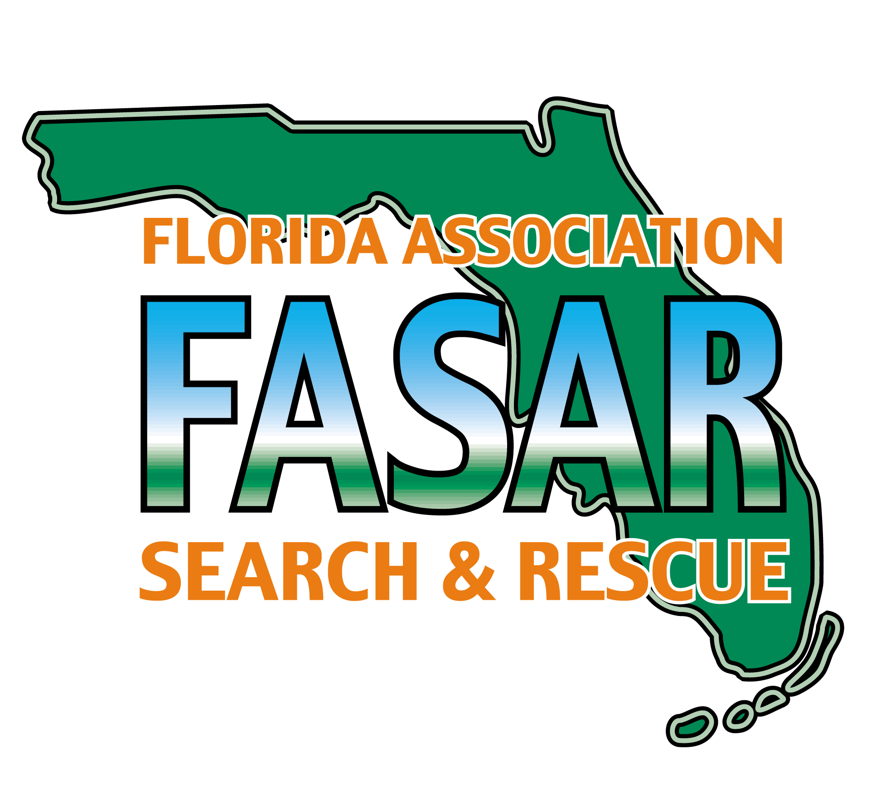

**Committee**

Allen Willis

***Chairman***

Larry Doerffel

***Vice Chairman***

Andrew Capeletti ***Secretary***

Jeff Strickland ***Immediate Past Chairman***

**Regional Reps**

Mike Landis

***Region 1***

Kurt Hindle

***Region 2***

Austin Gamble

***Region 3***

Anthony Daugherty ***Region 4***

Spencer Bashinski

***Region 5***

Glen Van Brunt

***Region 6***

Scott Dean

***Region 7***

**Liaisons**

Greg DeWitt

***FFCA***

Jeff Strickland

***FSFM***

Barry Shaw

***FWC***

Kasey Crowe

***FFS***

Karl Morgan

***BF&A***

Maj. Scanlon

***CERF-P***

*A Professional Interest Section of the Florida Fire Chiefs’ Association*

**Mission**

Unify and coordinate the efforts of SAR Responders in the State of Florida.

(Florida Fire & EMS Conference 2025)

State TRT, FASAR TSG, Logistics Work Group, and FASAR Business Meeting have been combined into one continuous session to improve efficiency, and respect members' time.

January 6th, 2025, 1015 hrs. meeting called to order

Meeting Minutes (TRT)

*M Brown TRT Chair*

Roll Call of Regional team’s present

TRT Teams contact list updated, New TRT Team added, St Lucie County #544

10 new TRT teams since 2019, (29% increase in team numbers)

9 departments are currently interested in forming TRT teams. Walton, Alachua, Wakulla, Suwannee, Hernando, City of DeLand, Palm Bay, Key West, Coral Gables.

TRT calls in State- 9 high angle/rope rescue, 9 VMR, 4 SCT, 1 Con Space

ORE to be emailed to teams, team evals score of 90 or better for activation.

Equipment topic regarding drones?

*(Willis)* FDLE has authorized a grant to reimburse the purchase cost of current unauthorized DGI drones owned by the department. The grant will also allow cover the replacement cost of like drone by the currently approved vendor.

Open Discussion-

TRT involvement with storm response?

(*Strickland)* TRT’s mission is specific to local response. USAR teams come with TRT-trained members. TRT teams can build up to a type one SWT/MRP for possible state typing and response. Funding-dependent training may be provided for TRT teams at the state level. Type one SWT can be utilized via EMAC requests if available. Any Swift Water capable TRT team must meet resource typing requirements. (Staffing/Equipment)

*(Open Discussion)*

TRT-trained personnel assigned to EST?

*(TJ Lyon)* TRT is typed separately from EST, TRT must be requested as a separate function from EST for ESF 4 tracking purposes.

Standard Medical checkoff for TRT members regarding Con Space and HazMat entry?

*(Strickland, Willis*) AHJ medical clearance authorization should be utilized, no specific state requirement for medical clearance.

TRT team's interest in MOBEX, 5 teams’ participation to be discussed in Training meeting.

Call for any other point of discussion regarding TRT, *(Willis)*

Allen Willis motioned to adjourn the TRT portion of the meeting, and the motion was seconded.

TRT portion adjourned

Break

Meeting Minutes (FASAR TSG)

January 6th, 2025, 1100 hrs. meeting called to order

*Jeff Rouse TSG Chair*

LBR/SHSGP

*(Kohnke)*SHSGP funding opportunities are becoming more difficult to receive, the federal funding amount continues to decrease, and requests are more difficult to keep above the funding threshold. Funding has been granted for this year.

*(Kohnke/Michelle)* TEEKS will host training courses for this year's training cycle, funding for training has been received, One Million dollars for classes. i.e.: Specialty, IST position specific, and MOBEX exercise. State Legal and TEEKS legal dept. are reviewing funding laws and regulations before authorization and release of monies and proposing an LBR for a 5.5-million-dollar sustainment budget to fund USAR and MARC, HazMat, and USAR administrative staffing at the state 4/9 office.

A proposed TEEKS budget request of 500 thousand dollars for yearly training. Developing a proposal for funding a state-level position for a full-time USAR coordinator, and a full-time HazMat coordinator.

*(FASAR TSG)*

A tentative schedule has been distributed; a modified schedule is forthcoming. Funding is focused on USAR teams.

*(Director Rice)* Please ensure enrolled participants attend class. State Legislative groups review the attendance of training classes to justify future funding.

(Kohnke/Zielonka) All Logistics managers for USAR teams need to update the vehicle inventory and identify gaps in team equipment inventory for sustainment funding. This gap analysis is due by April, the funding source will be dedicated in June.

**Training timelines**. *(Strickland)*

An adjustment has been made to the USAR All Hazards training schedule; dates are solidified. 4/9 IST training classes are open to all, USAR training is team specific. The registration link is found in the Survey Monkey embedded in the email. Proposed dates for all training classes are pending state approval of funding.

*(Rouse)-* August is the maximum extension of funding, USAR classes will be dependent on the hosting agency’s ability to facilitate classes, dates, and instructors.

FL-1 Logs,

FL-2 K9,

FFC - Plans,

FL-7 Water rescue Specialist proposed for March.

My DB solutions, implementation, and use of the program for inventory of equipment and tracking of team credentialing. Lead agencies are responsible for maintaining annual subscriptions, a proposal will be discussed for adding MyDB to the sustainment funding.

*(Strickland)***NQS**- Credentialing for position-specific IST roles has been finalized by the FSFM office. Position-specific task books must be completed and contain signatures and dates, from two separate events showing proficiency in skills. Final signoffs can be completed by team program managers, department training chiefs, and the department's fire chief, who can sign as the agency administrator.

TPAM (training manual) Meeting schedule bi-annual with team training managers.

*(FASAR TSG)*

*(Rouse/Chappel)* Mobex exercise in February, 7 teams participating, (IWI possibility) high-pressure administrator challenges, logistical layout of area for team staging footprint. Camp Blanding, FLTF-5 training grounds, and Clay County EOC for IST members.

February 24th for IST members,

February 25th, 1300, check-in for USAR Teams

February 26th, 0700-1600, exercise

February 27th, 0800 AAR, 0900 Demob.

Please advise Scott Chappel of team size, pax count, and any requests for specific training exercises. i.e.: boat ops, setting up BOO, K-9 operations.

Participants will be, State Task Forces, MARC, SERP-P, FL State Guard.

*(Chief Downey)—The legislative initiative for sustainment funding (FS633) and the direct oversight of Florida USAR will be supervised by the State Fire Marshals office. The bill is included in the next legislative package and has the governor's support*.

*(A Willis)* This event, which will be held at the capitol on April 3rd, 2025, highlights the fire service in the state of Florida and affords an opportunity for state lawmakers to interact and learn what the funding supports and the justification of future funding.

**Logistics Workgroup**

Requesting all Task Force logistics managers to use ICS 213 for any logistical requests, ICS 213rr does not allow for enough specificity for some requested items. All damaged equipment replacement requests must also have a copy of an ICS 214 to justify replacement. Team Rosters must be submitted to Plans and Logistics to ensure accurate pax count for personnel tracking and logistical support.

When using the FEMA Cashe list for equipment replacement, items do not have to be the same as the one listed, it can be any brand as long as it meets or exceeds listed specifications.

MyDB solutions for equipment, personnel, and credentialing for all teams are essential for tracking and accountability of assets purchased by the state. It streamlines audits at the state level and provides justification for replacing equipment due to aging out.

Motion to adjourn, motion seconded. Adjourned

Break for Lunch @ 1210hrs

Meeting Minutes (FASAR)

January 6th, 2025, 1315 hrs.

*(A Willis)* Meeting was called to order

*Agenda-* Elections for Vice Chair, and odd region representatives, FASAR business

Roll call of regional representatives, any proxy attendees are unable to vote in election.

Eligible Vice Chair candidates, Larry Doerffel and Jeff Rouse are present.

Candidates were provided an opportunity to address the group before voting. Committee members and Regional reps voted in the Vice-chair election, votes were collected by Brian Eichholz, and the count was witnessed by the secretary for accuracy.

Vice-chair results, Larry Doerfful with 2 votes, Jeff Rouse with 7 votes. Jeff Rouse was elected the new FASAR Vice-chair. Term to begin at July FASAR meeting.

Odd region votes were cast by attending members of the candidate's region.

Results recorded

* Vice-chair Jeff Rouse
* Region 1 Mike Landis
* Region 3 Jessie Brown
* Region 5 Spenser Bashinski
* Region 7 Arturu Abreu

**FEMA US&R update**

*(Strickland)* Full-scale USAR exercise in Texas in February, NQS ad hoc group developing credentialing for Position Specific Task Books for IST.

IST information will be detailed at the scheduled IST meeting at this conference.

*(FASAR)*

**SUSAR**

SUSAR update, over 700 in attendance. The conference was very successful,

2025 SUSAR conference dates are November 10th, 11th, 12th 2025. November 5th thru 7th 2025, SUSAR pre-conference classes.

RFP for classes will be emailed on March 1st, 2025, for interested participants. The deadline for RFP will be May 1st, 2025.

**Reports**

Working Groups

TRT – *Brown*- 39 teams green 4 red, 10 new team interest statewide.

**Region Reports** – Regional Reps, nothing to report.

Open discussion and review of TRT, Training Group, and FASAR topics

Next meeting

July 11-15, 2025, FFCA Executive Development Conference Miami FL (Hotel TBD)

Adjourn motioned.

Meeting adjourned.